**Python and Bio-Python**

Assignment - 6

Practical Solving:

1.     Write a program to check whether a number is prime or not

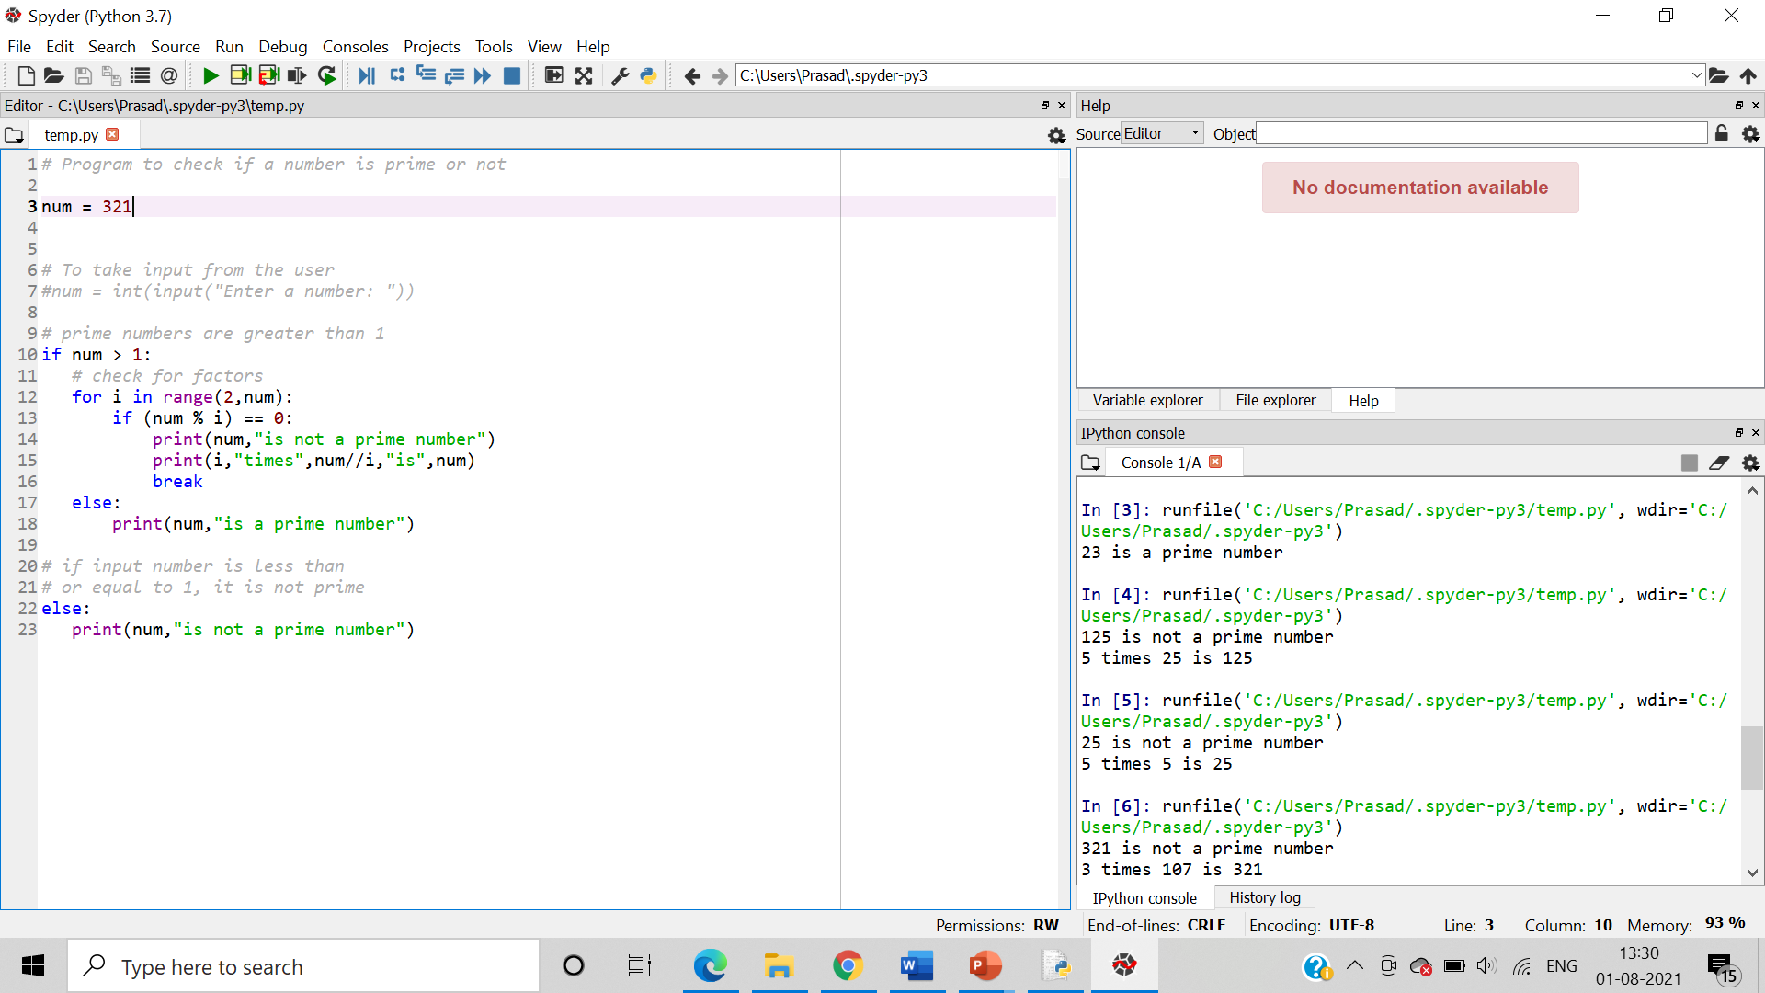

2.     Write a program to determine whether the number entered is Armstrong or not

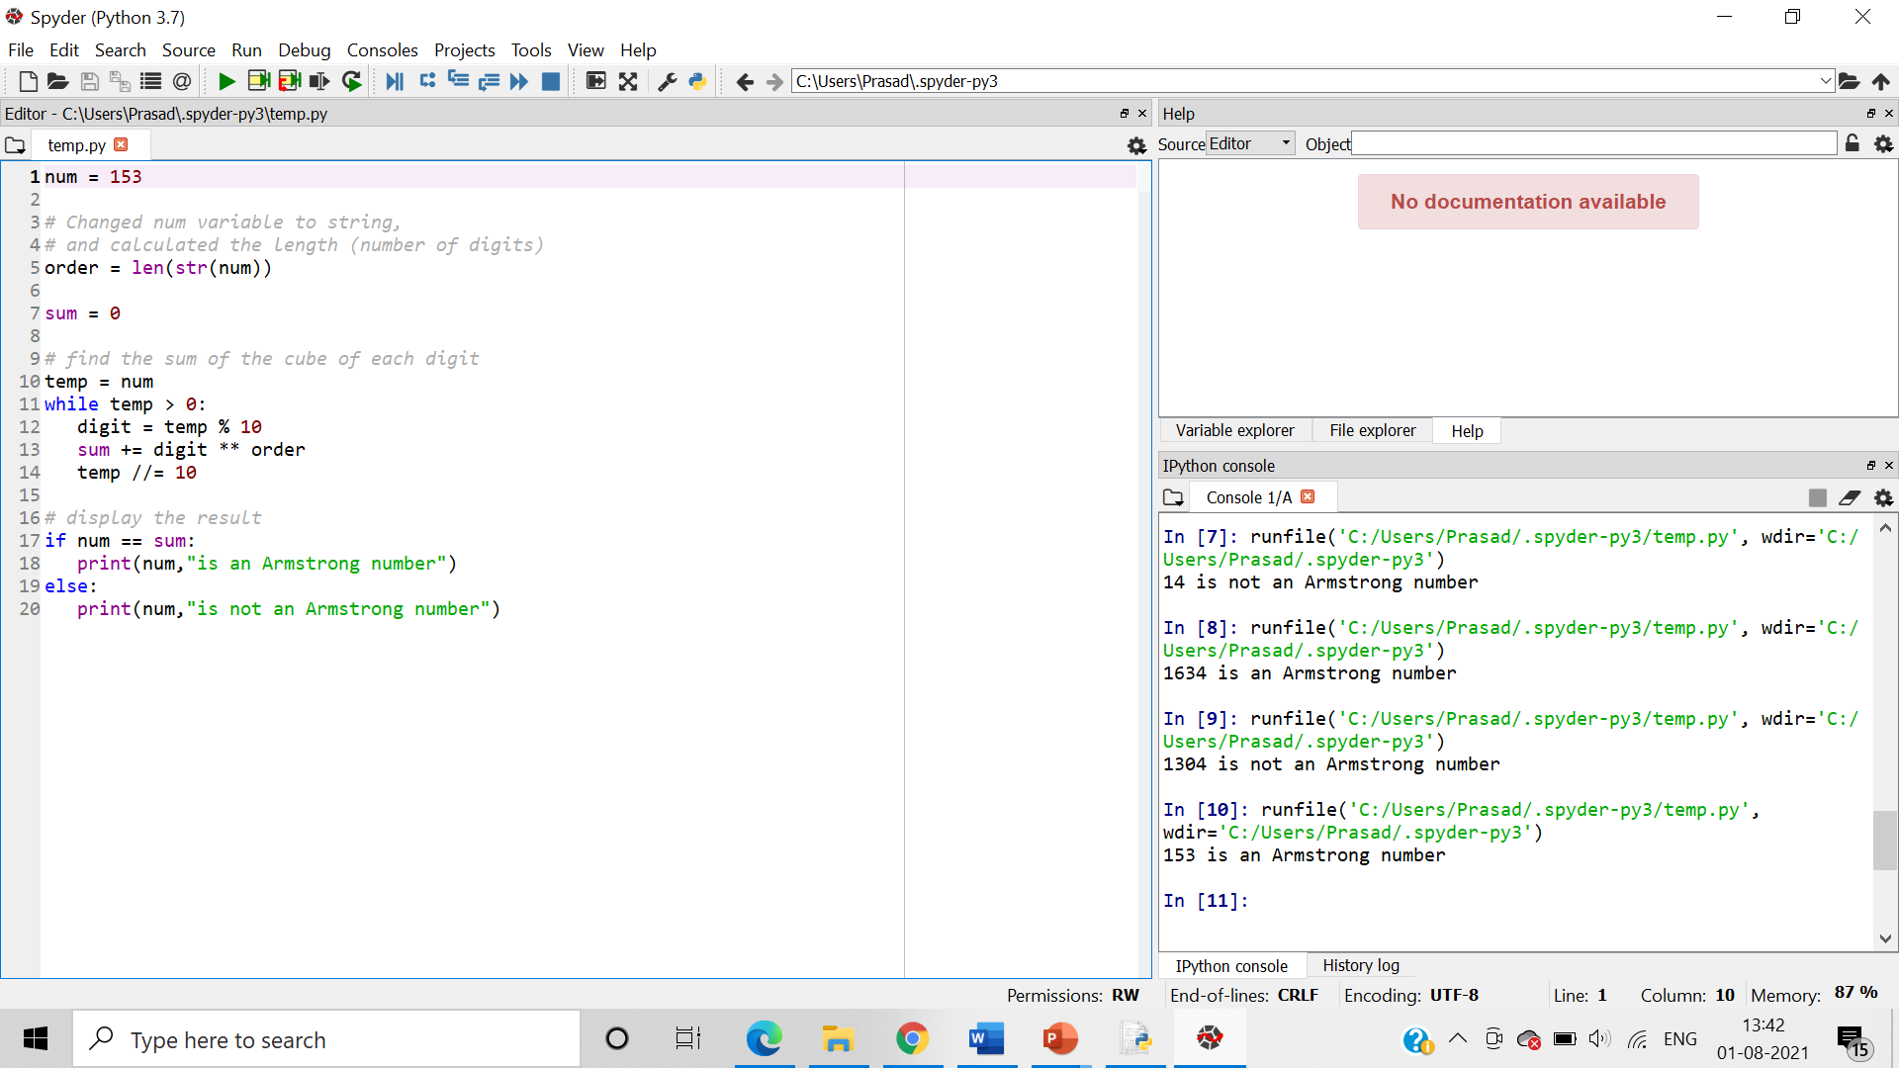

3.     Write a program to calculate the factorial of the number entered by the user

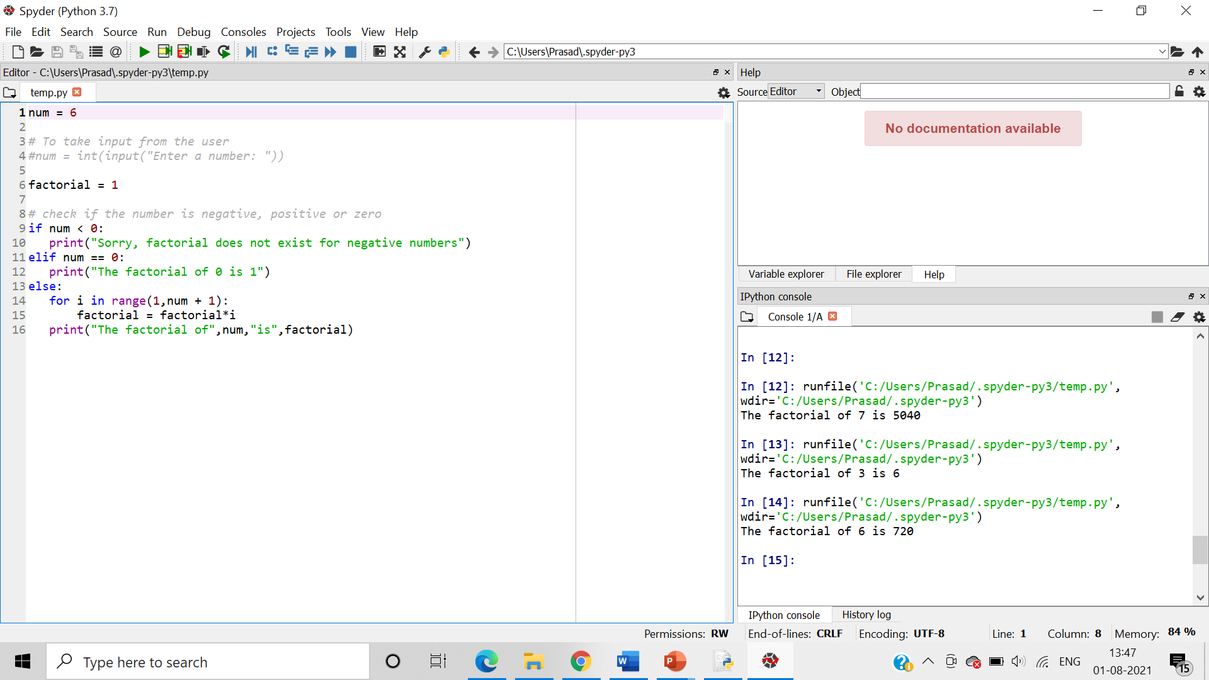

4.     Print all odd and even numbers separately entered in the user defined range

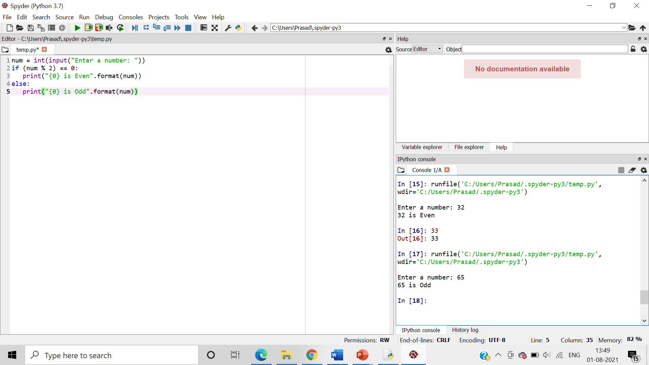

5.     Write a program to reverse words in a given String in Python

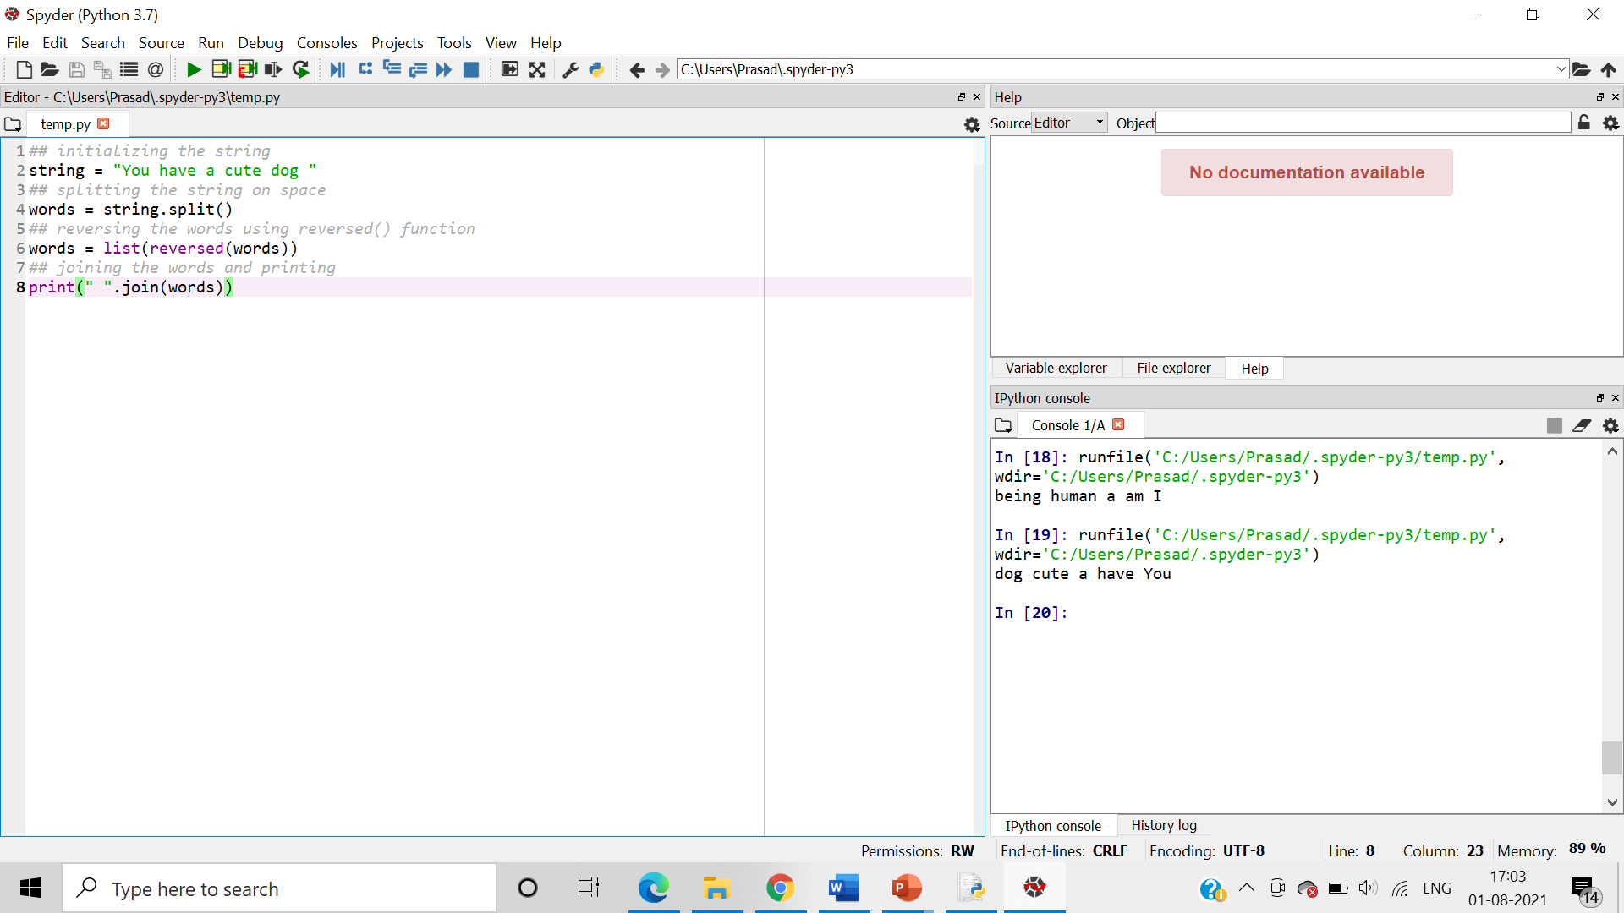

6.     Write a program to calculate the frequency of bases in the DNA sequence submitted by the user

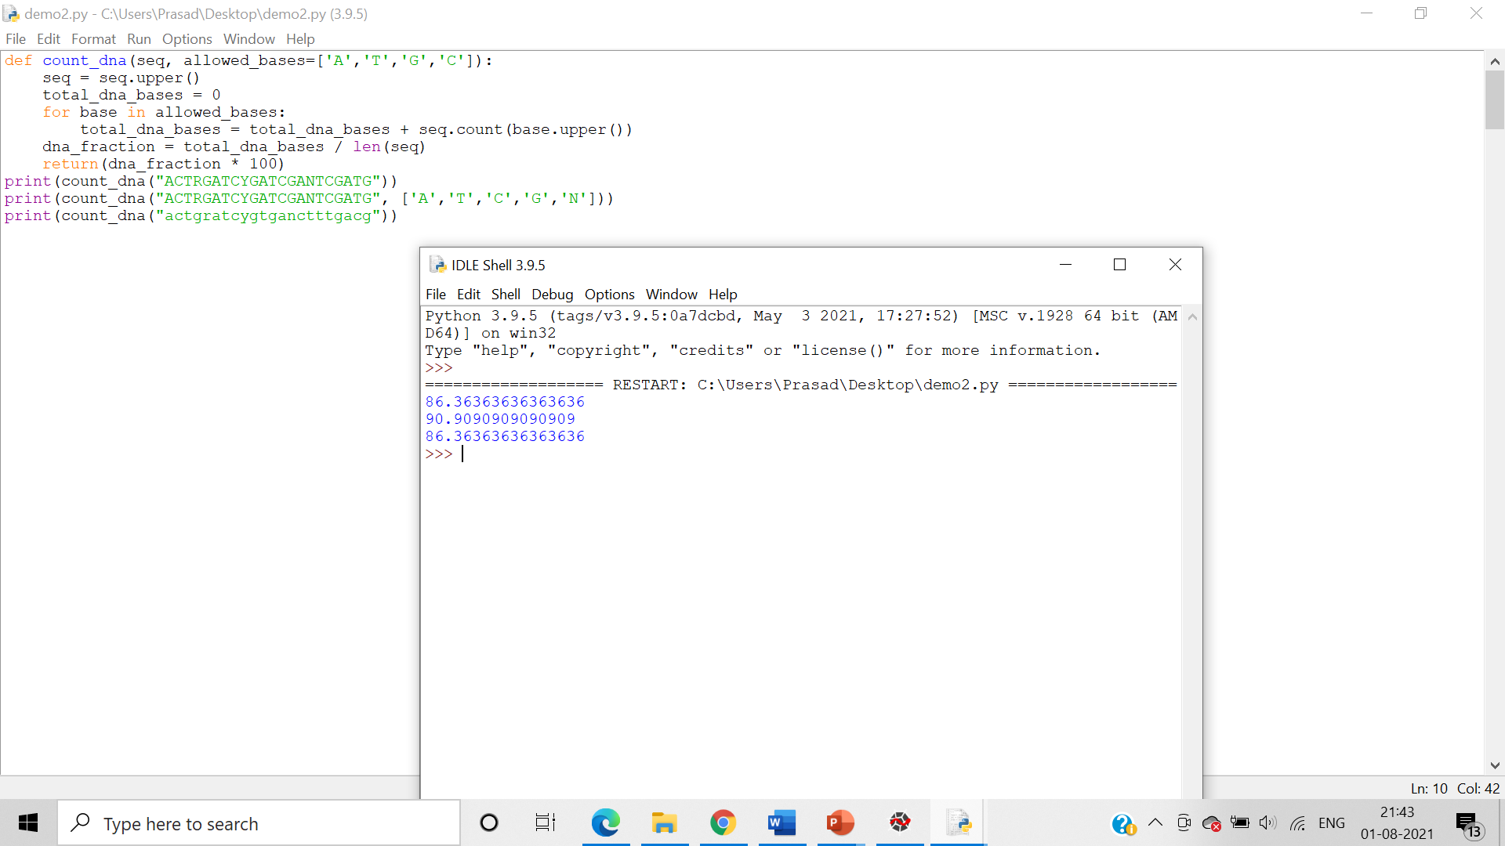

7.     Write a program to sort the elements of a dictionary in two ways - i) according to keys and ii) according to values

i) according to keys

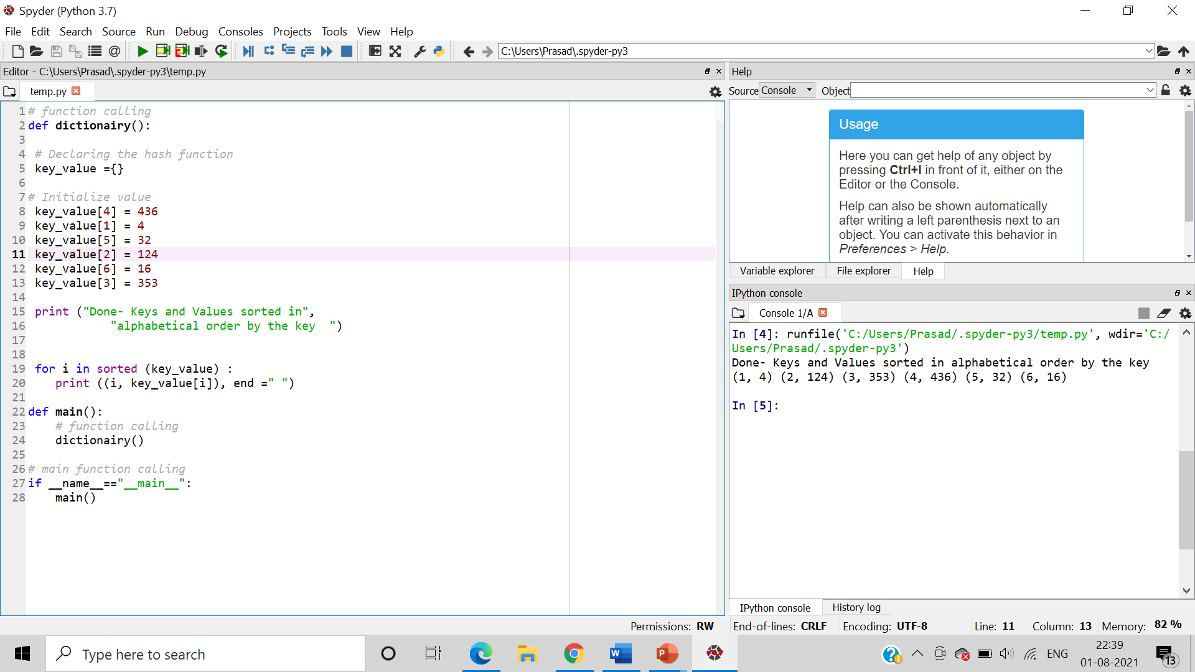

ii) according to values

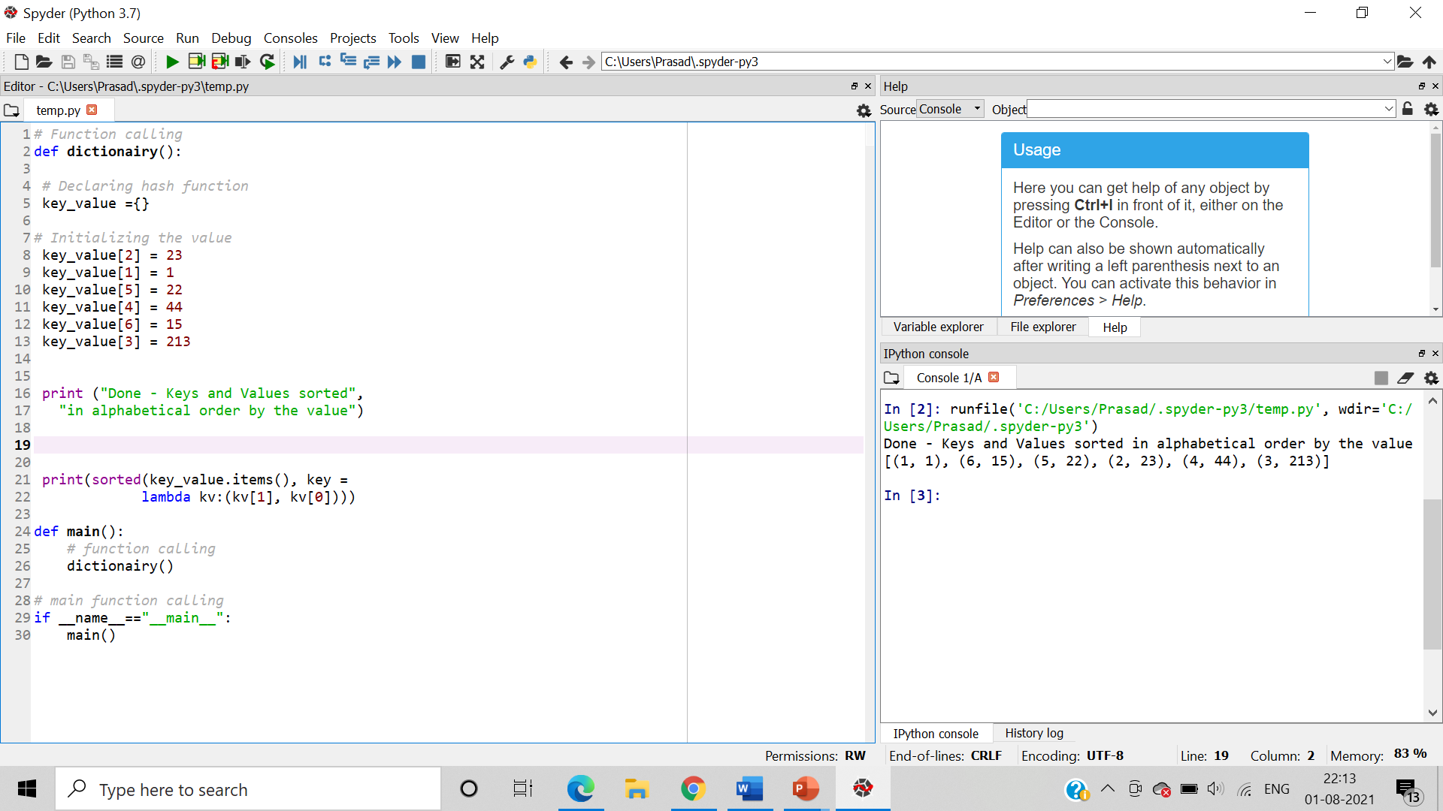

8.     Write a program to create grade calculator using dictionaries

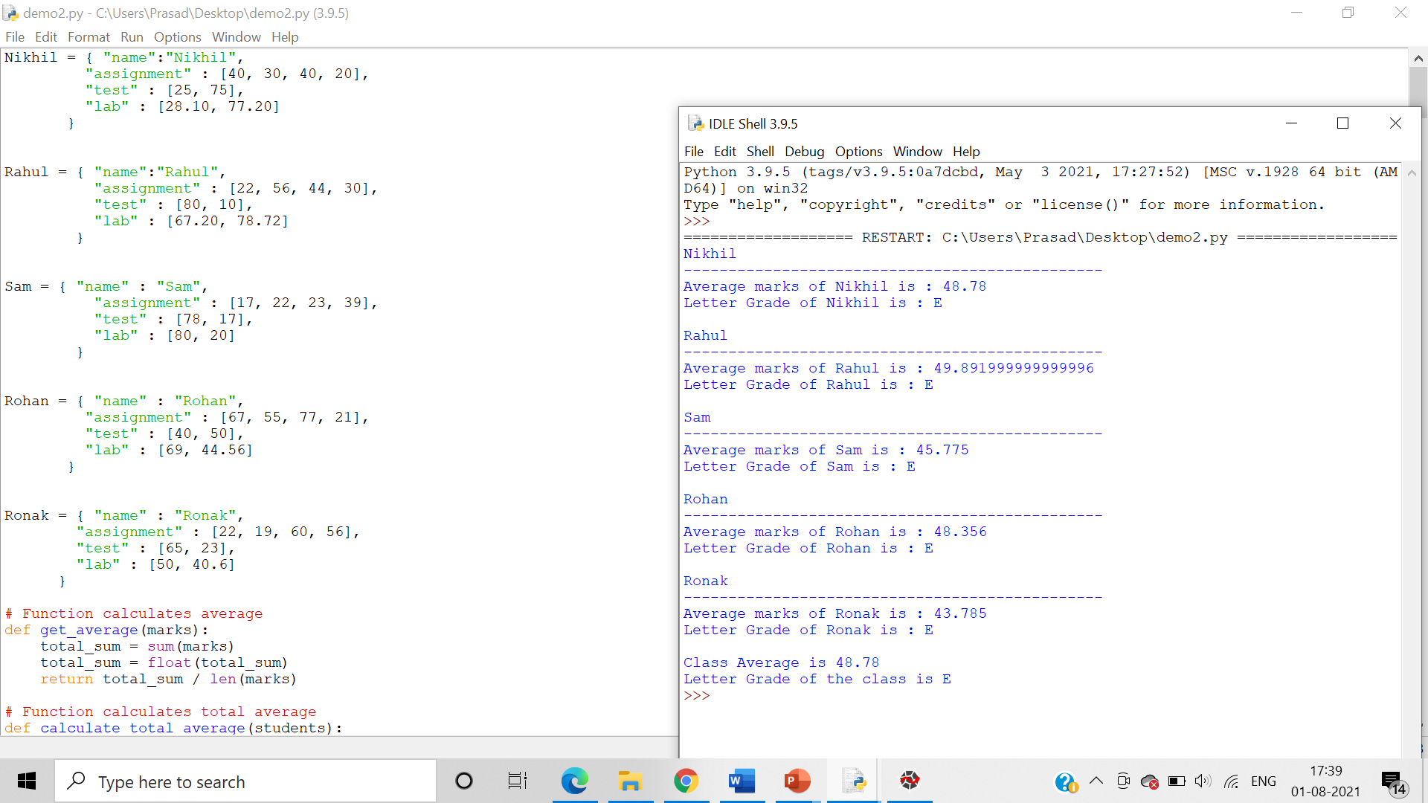

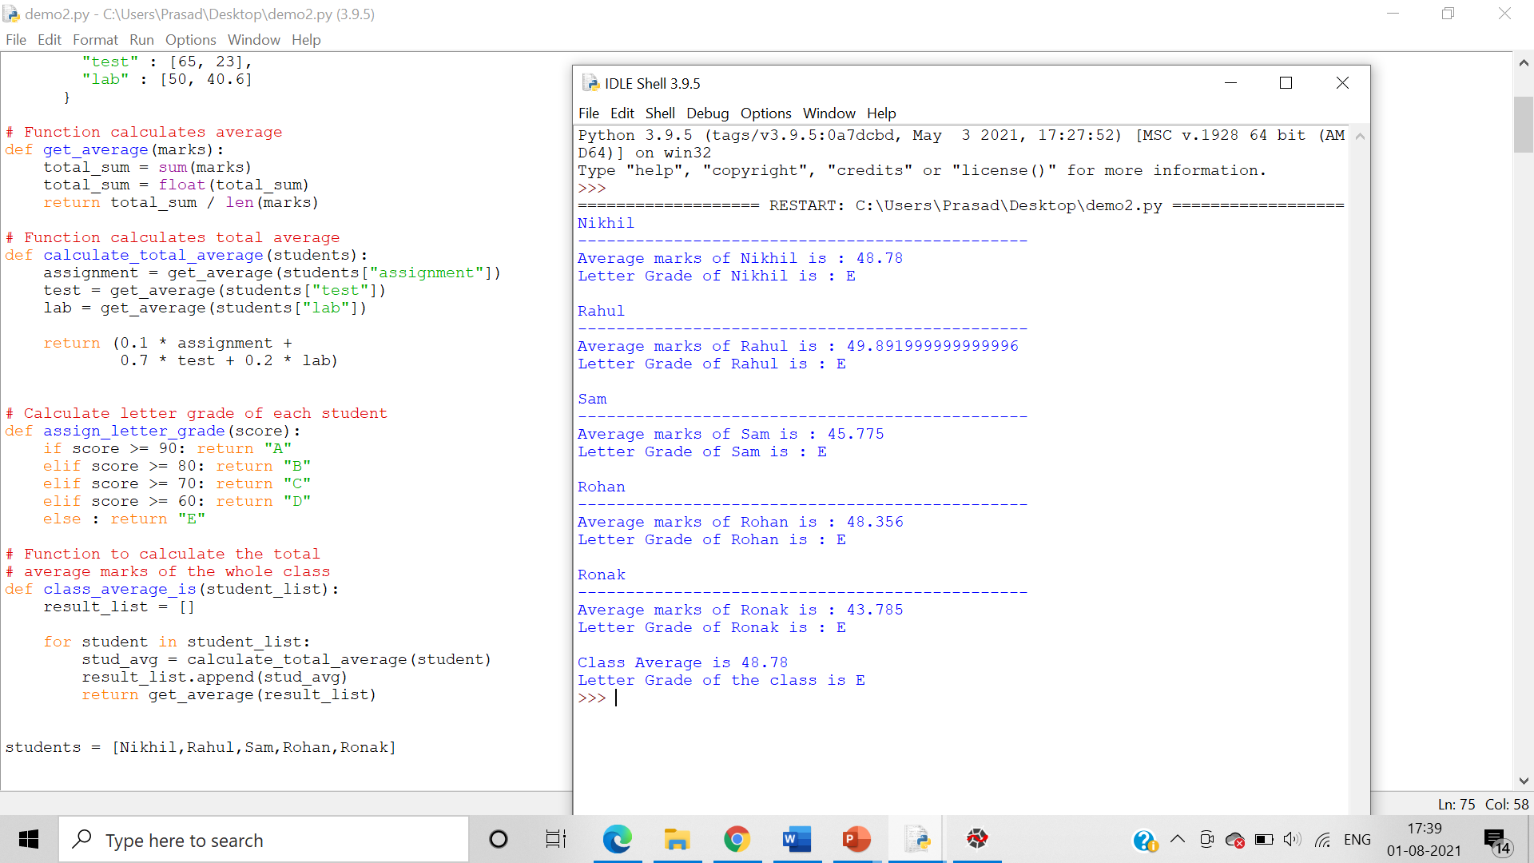

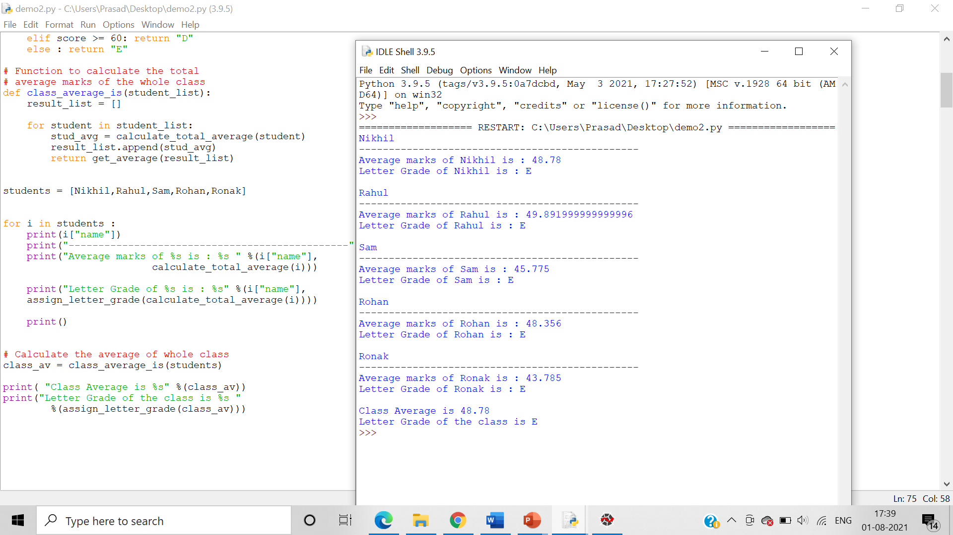

9.     Write a program to calculate Molecular weight of the peptide sequence submitted by the user

